QUESTION ONE
a)
library(MASS)
data(crabs)
'data.frame': 200 obs. of 8 variables:
The crab data is made up of 8 variables with 200 observed values with sp and sex being categorical values and the other variables being numerical.

b)
data("crabs")
str(crabs)
summary(crabs)
head(crabs)

head(crabs)
sp sex index FL RW CL CW BD
1 B M 1 8.1 6.7 16.1 19.0 7.0
2 B M 2 8.8 7.7 18.1 20.8 7.4
3 B M 3 9.2 7.8 19.0 22.4 7.7
4 B M 4 9.6 7.9 20.1 23.1 8.2
5 B M 5 9.8 8.0 20.3 23.0 8.2
6 B M 6 10.8 9.0 23.0 26.5 9.8
The structure is data frame
c)
table(crabs$sp)
table(crabs$sex)
tab species_sex <- table(Species = crabs$sp, Sex = crabs$sex)
tab_species_sex
prop.table(tab_species_sex)
prop.table(tab_species_sex, margin = 1)
prop.table(tab_species_sex, margin = 2)

d)
barplot(tab_species_sex, beside = FALSE, legend.text = TRUE,
xlab = "Species", ylab = "Count",
main = "Composition by Species and Sex")
BARPLOT

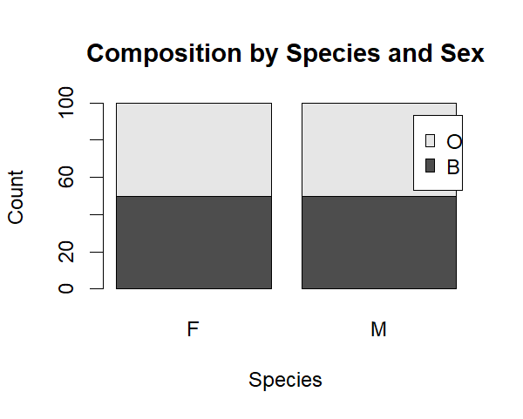

e) From the graph the dataset is balanced across the four groups

QUESTION TWO
a)
boxplot(BD ~ interaction(sp, sex, sep = "_"), data = crabs,
xlab = "Group (Species_Sex)", ylab = "Body Depth (BD)",
main = "Body Depth (BD) by Species and Sex")

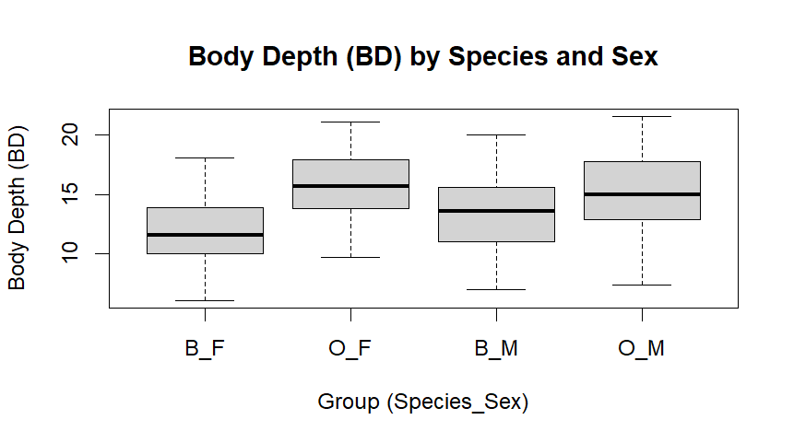

b)
bp <- boxplot(BD ~ interaction(sp, sex, sep = "_"), data = crabs, plot = FALSE)
outliers_df <- data.frame(group = bp$names[bp$group], outlier_BD = bp$out)
outliers_df

outliers_df [1]group outlier_BD<0 rows> (or 0-length row.names)
There is no outlier
QUESTION THREE
a)
par(mfrow = c(1, 2))
hist(crabs$CL[crabs$sp == levels(crabs$sp)[1]],
main = paste("CL Histogram:", levels(crabs$sp)[1]),
xlab = "Carapace Length (CL)")

hist(crabs$CL[crabs$sp == levels(crabs$sp)[2]],
main = paste("CL Histogram:", levels(crabs$sp)[2]),
xlab = "Carapace Length (CL)")
par(mfrow = c(1, 1))

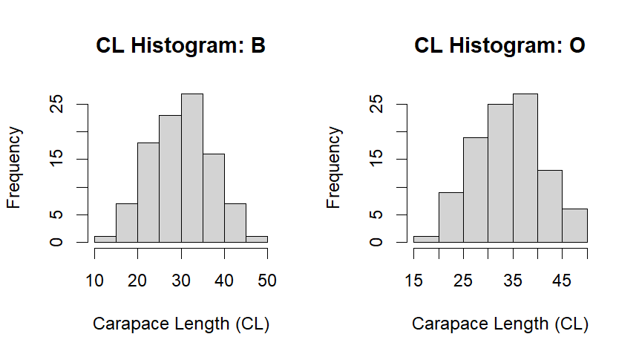

b)
by(crabs$CL, crabs$sp, summary)
skewness <- function(x){
x <- x[is.finite(x)]
m <- mean(x); s <- sd(x)
mean(((x - m)/s)^3)
}
by(crabs$CL, crabs$sp, skewness)

crabs$sp: B
Min. 1st Qu. Median Mean 3rd Qu. Max.
14.70 24.85 30.10 30.06 34.60 47.10
The minimum length is 14.70 and the maximum is 47.10 while 25% of the data values are less than 24.85 and 75% of the data values are more than 34.60 and half of the lengths are more or less than 30.10. Also the mean length is 30.06. The mean is almost equal to the median which makes the data normally distributed as we see from the histogram
crabs$sp: O
Min. 1st Qu. Median Mean 3rd Qu. Max.
16.70 29.20 34.55 34.15 39.40 47.60

The minimum length is 16.70 and the maximum is 47.60 while 25% of the data values are less than 29.20 and 75% of the data values are more than 39.40 and half of the lengths are more or less than 34.55. Also the mean length is 34.15. The mean is slightly less than the median making the data skewed to the left.

QUESTION FOUR
a)
overall_means <- colMeans(crabs[, c("FL","RW","CL","CW","BD")])
_overall_means

overall_means
FL RW CL CW BD
15.5830 12.7385 32.1055 36.4145 14.0305
b)

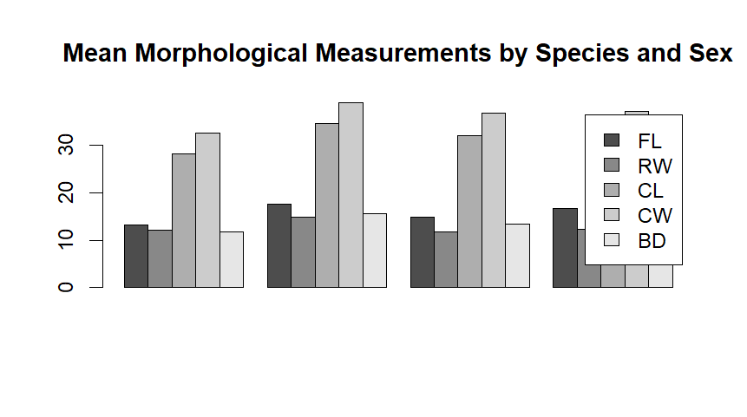
QUESTION FIVE
a)
pairs(crabs[, c("FL","RW","CL","CW","BD")],
main = "Scatter Matrix of Crab Measurements")

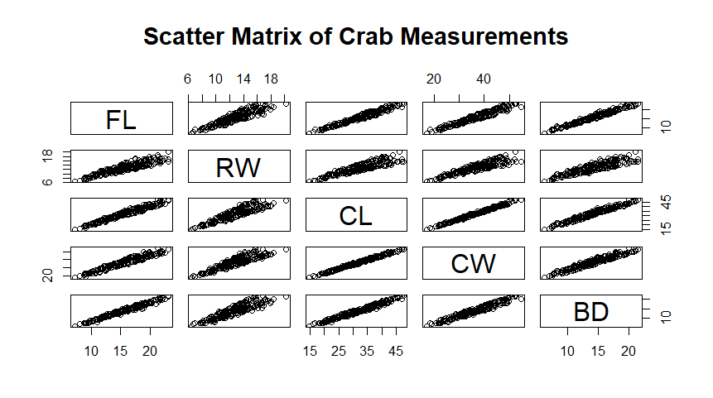
b)
cor(crabs[, c("FL","RW","CL","CW","BD")])

FL RW CL CW BD
FL 1.0000000 0.9069876 0.9788418 0.9649558 0.9876272
RW 0.9069876 1.0000000 0.8927430 0.9004021 0.8892054
CL 0.9788418 0.8927430 1.0000000 0.9950225 0.9832038
CW 0.9649558 0.9004021 0.9950225 1.0000000 0.9678117
BD 0.9876272 0.8892054 0.9832038 0.9678117 1.0000000

There is a very strong positive correlation among variables. As one variable increases the other also increases and as it decreases the other also decreases.

QUESTION SIX
The crabs data set consists of 8 different variables with 200 obervations.

